**ASSIGNMENT 3.1**

**on**

**Machine Learning Basics**

**Submitted by:**

**Haseebullah Shaikh (2303.KHI.DEG.015)**

and

**Faiza Gulzar Ahmed (2303.khi.deg.001)**

**Dated :** 18th Apr 2023

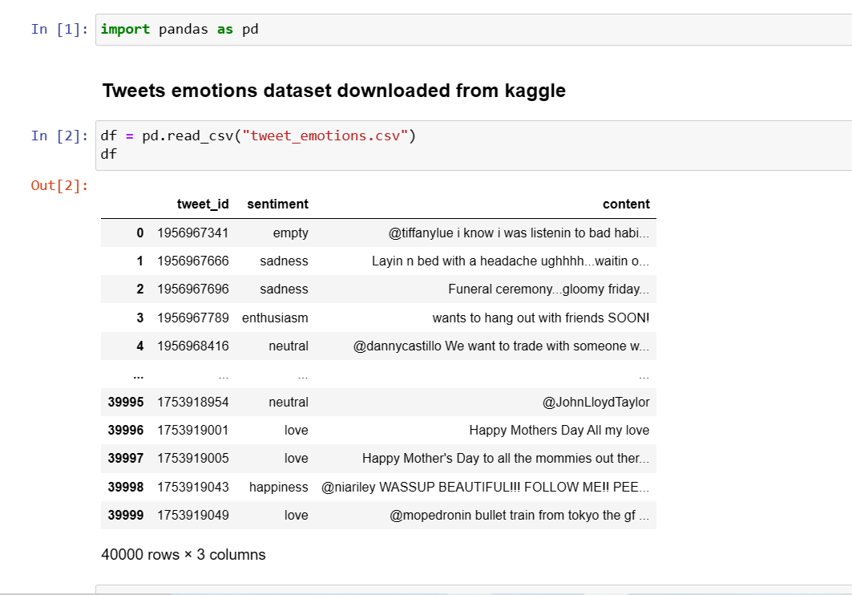**Task 01:** Implement a label coder for categorical data using pure python, pandas and numpy.

